Ministry of Science and Higher Education of the Russian Federation

Federal state budget educational institution for higher education

IRKUTSK NATIONAL RESEARCH TECHNICAL UNIVERSITY

Baikal School of BRICS

TERM PAPER

on the academic discipline

“Project Management”

Student’s name: Mark Ijeoma Precious
Group AIb-23-1

Academic and Standard Supervisor:
Senior Lecturer: Mearaf

Irkutsk, 2025

CONTENTS

1. INTRODUCTION 3
2. DATASET DESCRIPTION 5
3. METHODOLOGY 7
3.1 Data Preprocessing 7
3.2 Data Cleaning Process 7
3.3 Feature Engineering 8
3.4 Word Embeddings 9
3.5 LSTM Model 10
3.6 Transformer Model 12
3.7 BERT Fine-Tuning 13
4. EXPERIMENTAL RESULTS 15
4.1 Model Comparison 16
5. DISCUSSION 17
5.1 Model Strengths 17
5.2 Observations 17
6. CONCLUSION 18
REFERENCES 20

1. INTRODUCTION
Mental health problems and suicidal thoughts have become major global concerns, especially with the increasing use of social media platforms where individuals frequently express emotions, stress, anxiety, and depression. Detecting suicidal thoughts early can help mental health professionals provide timely intervention and support.
Natural Language Processing (NLP) and Deep Learning techniques have shown significant success in text classification tasks, including sentiment analysis and mental health detection. In this project, multiple machine learning and deep learning approaches were implemented to classify social media posts into suicidal and non-suicidal categories.
The project aimed to build a complete NLP pipeline using various techniques learned throughout the semester, including preprocessing, feature engineering, word embeddings, sequence models, attention mechanisms, transformers, and BERT fine-tuning.
Different models such as TF-IDF with Logistic Regression, Word2Vec, LSTM, Transformer, and BERT were implemented and compared to determine the most effective model for suicidal thought detection.
Objectives
The main objectives of this project were:
- To preprocess and clean social media text data
- To apply feature extraction and embedding techniques
- To implement machine learning and deep learning models
- To compare model performance using evaluation metrics
- To identify the best-performing model for suicidal text detection

This project is important because social media platforms contain large amounts of emotional and mental health-related text. An intelligent detection system can help identify users at risk and support early intervention strategies.
The developed system can assist:
- Mental health professionals
- Suicide prevention organizations
- Researchers in NLP and AI
- Social media monitoring systems


Figure 1- Mental Health / Social Media Effect
source:https://foothillsneurology.com/social-media-and-mental-health/

2. DATASET DESCRIPTION
The dataset used in this project was a social media text dataset containing suicidal and non-suicidal posts. Each text sample was labeled into one of two classes:
- Suicide
- Non-Suicide
The dataset consisted of a total of 232,074 text entries collected from online social media platforms where users expressed emotions, thoughts, stress, anxiety, depression, and daily experiences.
The dataset was balanced equally between both classes:
Class | Number of Samples
Suicide | 116,037
Non-Suicide | 116,037
This equal distribution helped prevent model bias during training and improved classification fairness.
The dataset contained various writing styles, emotional expressions, slang, abbreviations, and informal internet language, making the classification task more realistic and challenging.
The dataset was divided into the following:
- Training set
- Testing set
The training set was used to train machine learning and deep learning models, while the testing set was used to evaluate model performance and prediction accuracy.
A class distribution graph was also generated to visualize the equal distribution of suicidal and non-suicidal samples in the dataset.

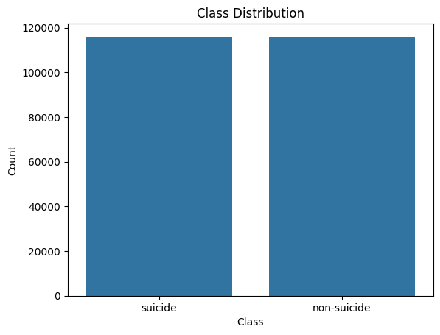
Figure 2- Visualization of the distribution
Source- compiled by author

The dataset contains Short and long text posts, emotional expressions Informal internet language, abbreviations, and slang; positive and negative sentiments, These characteristics made preprocessing and contextual understanding important for successful classification.

3. METHODOLOGY

3.1 Data Preprocessing
Data preprocessing was performed to clean and normalize the text before model training. The following preprocessing steps were applied:
- Lowercase conversion
- Punctuation removal
- Stopword removal
- Tokenization
Lowercase conversion helped standardize words by converting all text into lowercase format. Punctuation removal eliminated unnecessary symbols that do not contribute significantly to text meaning. Stopword removal removed common words such as “the”, “is”, and “and” to reduce noise in the dataset. Tokenization split text into individual words or tokens for further processing.
Preprocessing is important because raw social media text is often noisy and inconsistent. Proper preprocessing improves model accuracy, reduces computational complexity, and helps models learn meaningful patterns more effectively.

3.2 Data Cleaning Process
Additional cleaning operations included:
- Removing extra spaces
- Removing special characters
- Removing unnecessary symbols
- Standardizing text formatting
These steps improved text consistency and reduced irrelevant information.
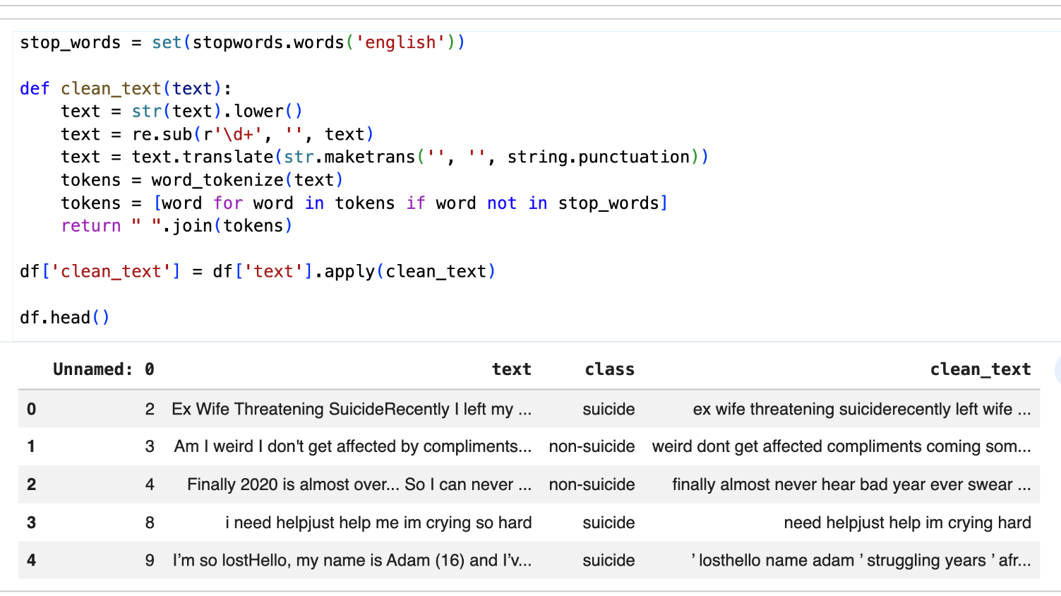
Figure 3 - Dataset Cleaning
source - compiled by author

3.3 Feature Engineering
TF-IDF (Term Frequency–Inverse Document Frequency) was used as the first feature engineering technique. TF-IDF converts text into numerical vectors based on word importance.
A Logistic Regression classifier was trained using TF-IDF vectors to classify suicidal and non-suicidal posts.
TF-IDF creates sparse representations where each document is represented by word frequencies. Frequently occurring important words receive higher weights, helping the classifier identify significant terms associated with suicidal thoughts.
Logistic Regression Classifier
Logistic Regression was selected because it is simple and computationally efficient and effective for binary classification and easy to interpret.
Although it is a traditional machine learning model, it provided strong baseline performance.
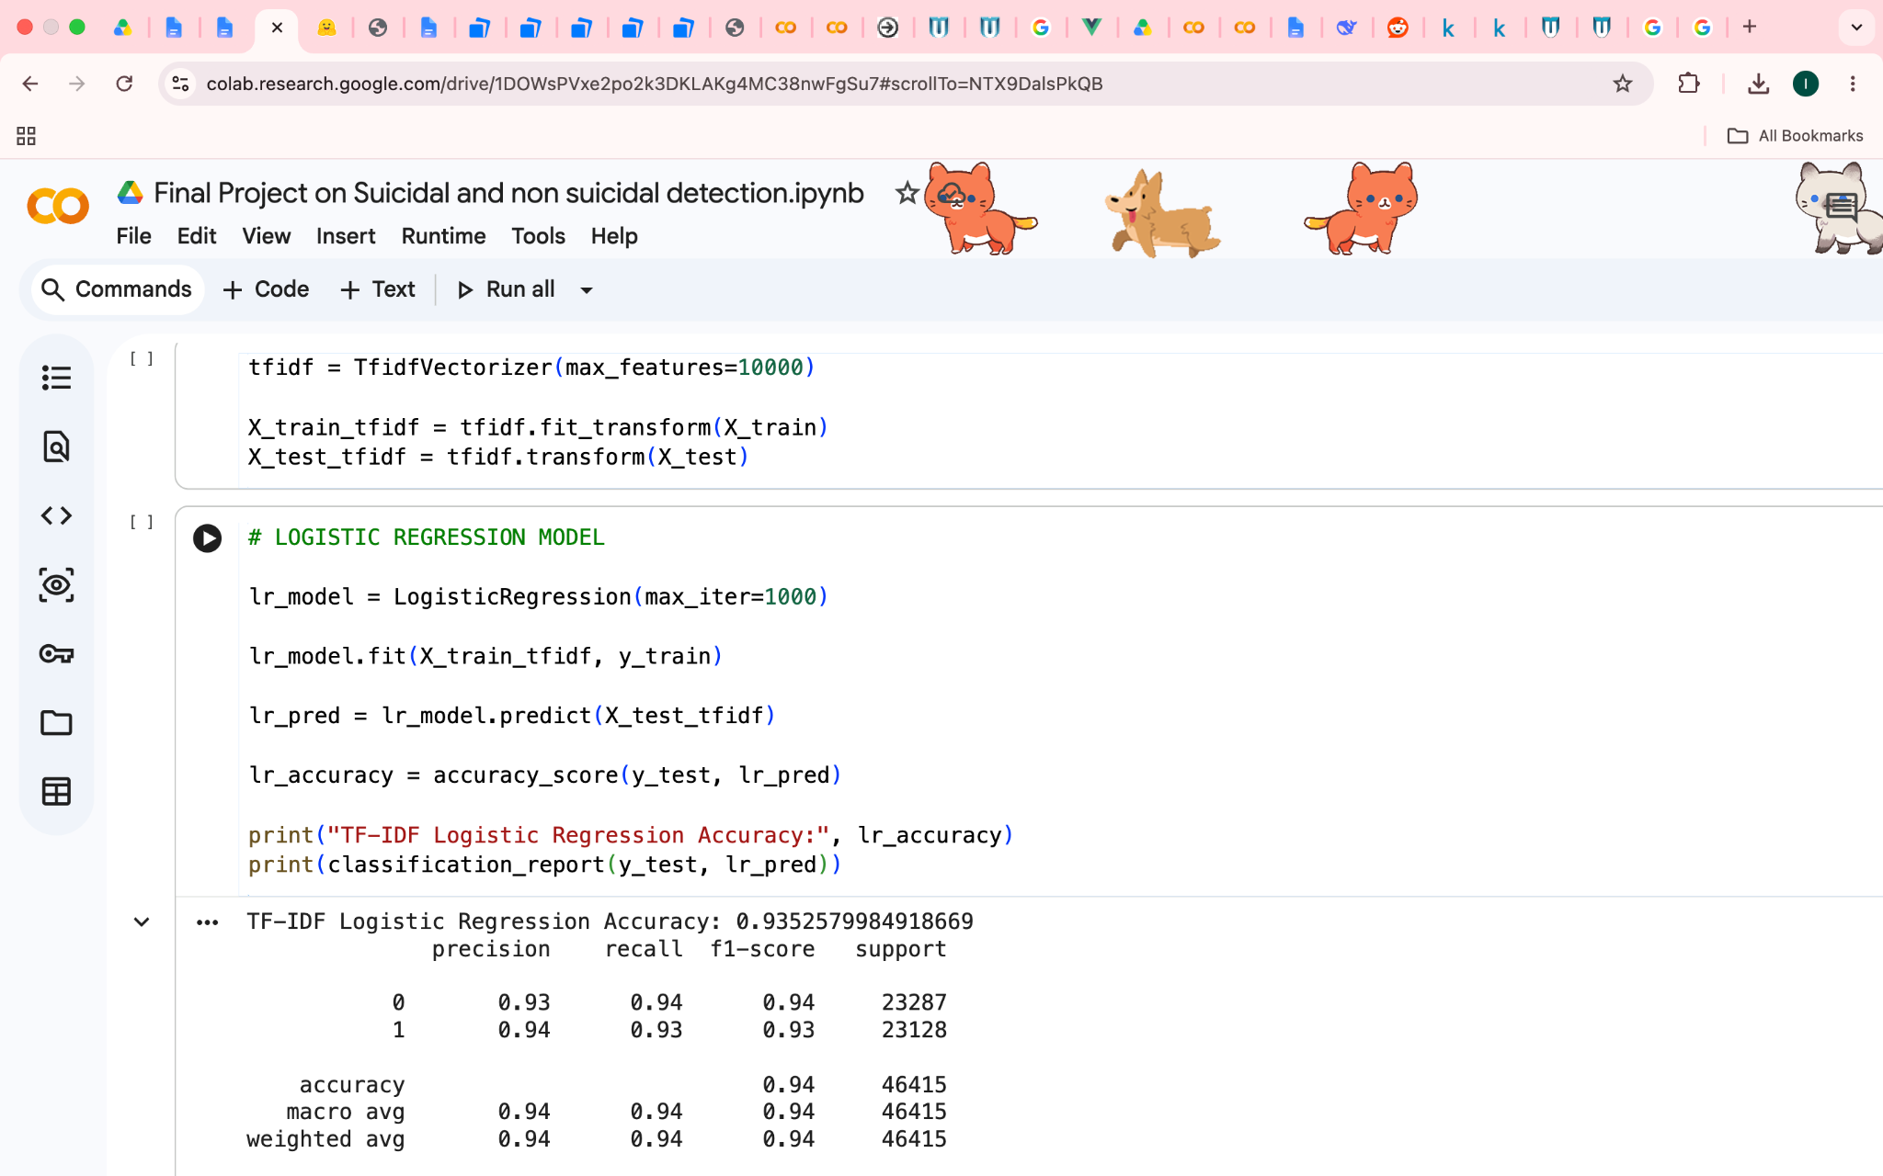
Figure 4 - Feature Engineering
Source - compiled by author

3.4 Word Embeddings
Word2Vec embeddings were implemented to capture semantic relationships between words. Unlike TF-IDF, Word2Vec learns dense vector representations where similar words have similar meanings.
The Word2Vec model was trained using tokenized sentences from the dataset. Sentence vectors were generated by averaging word vectors, and a Random Forest classifier was trained using these vectors.
Embeddings are better than TF-IDF because they capture contextual meaning and semantic similarity rather than relying only on word frequency.
Word embeddings provide semantic understanding, better contextual learning, reduced sparsity, and similar vector representation for similar words
This allows the model to better understand relationships between emotional words and suicidal expressions.
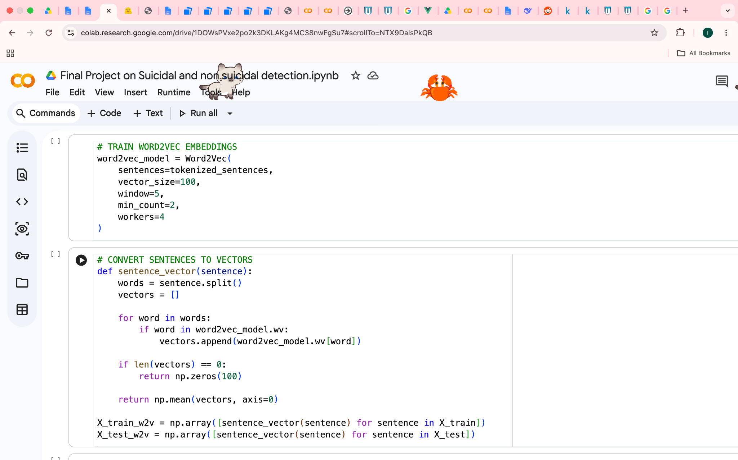
Figure 5 - Word Embedding
Source - compiled by author

3.5 LSTM Model
An LSTM (Long Short-Term Memory) neural network was implemented for sequence modeling. The model architecture included:
- Tokenization
- Padding
- Embedding layer
- LSTM layer
- Dense output layer
LSTM networks are highly effective for Natural Language Processing tasks because they preserve sequential information and long-term dependencies between words. Unlike traditional neural networks, LSTM models can remember important contextual information over long text sequences. This makes them suitable for detecting emotional and suicidal expressions where sentence structure and word order are very important.
Sequence order matters in language because changing word positions can completely change sentence meaning. For example:
- “I do not want to die”
- “I want to die”
Both sentences contain similar words but have completely different meanings. LSTM models are capable of understanding these sequential differences.
The LSTM model was selected because:
- It performs well on sequential text data
- It remembers previous contextual information
- It handles long-term dependencies effectively
- It improves understanding of emotional text patterns
- It performs better than traditional dense neural networks for NLP tasks
LSTM was particularly useful in this project because suicidal text often contains emotional context spread across multiple words and sentences.
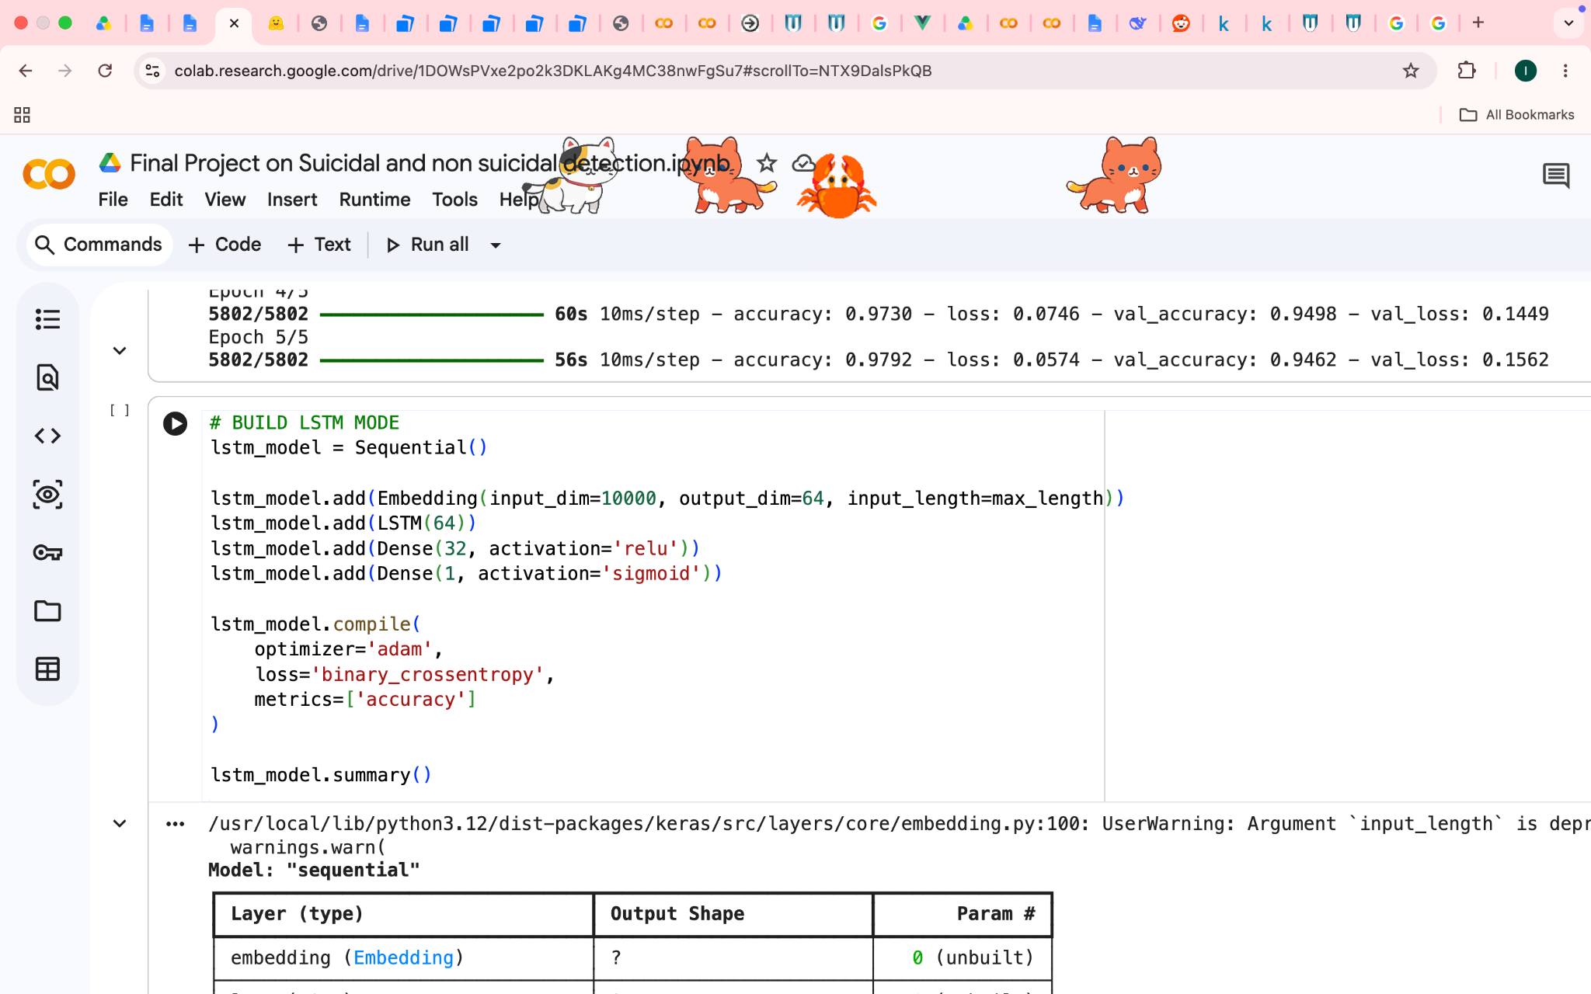
Figure 6 - LSTM Model
Source - compiled by author

Tokenization and Padding
Text sequences were tokenized and padded to ensure equal input length for the neural network.
Tokenization converts words into numerical sequences understandable by deep learning models. Padding ensures that all sequences have the same fixed length before being passed into the LSTM network.
Padding is important because deep learning models require fixed-size inputs during training.
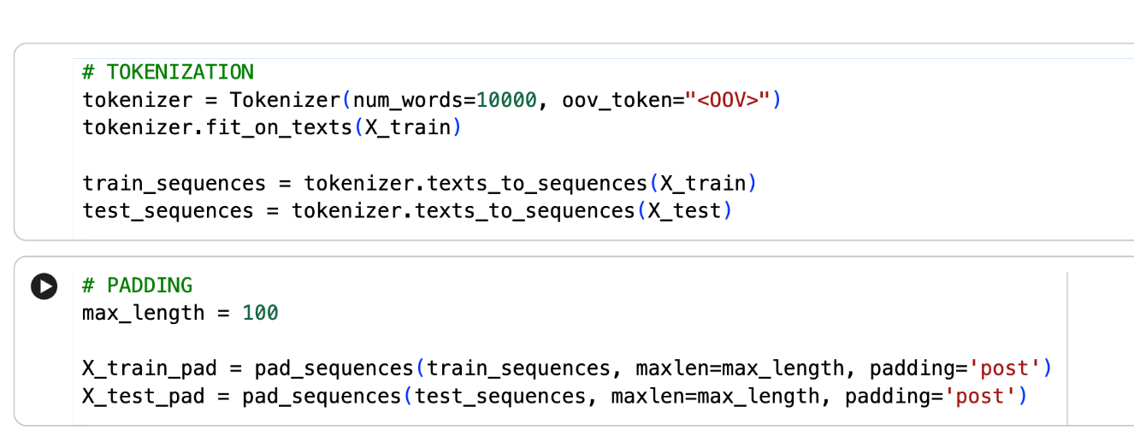
Figure 7- Padding and Tokenization
Source - compiled by author

3.6 Transformer Model
A transformer-based text classification model was implemented using MultiHeadAttention layers.
The model architecture included:
- Embedding layer
- MultiHeadAttention layer
- Pooling layer
- Dense output layer
Attention mechanisms allow the model to focus on important words in a sentence regardless of position. Transformers outperform LSTM models because they process text in parallel and capture long-range dependencies more efficiently.
The attention mechanism allows the model to identify important contextual words within text sequences. For example, emotionally significant words such as "hopeless," "depressed," "tired," and "worthless" receive higher attention and importance during prediction.
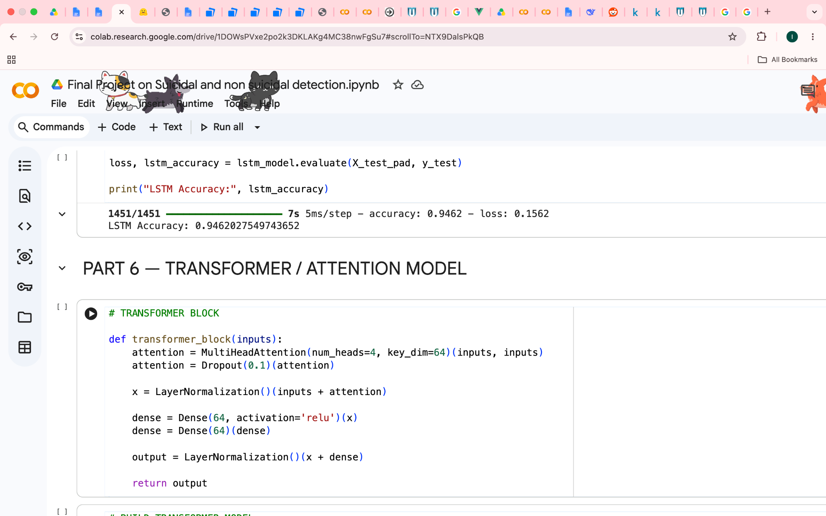
Figure 8 - Transformer Model
Source - compiled by author

3.7 BERT Fine-Tuning
BERT (Bidirectional Encoder Representations from Transformers) was fine-tuned using Hugging Face Transformers.
The implementation included:
- BERT tokenizer
- Pretrained BERT model
- Fine-tuning
- Evaluation
Pretrained learning means the model was already trained on massive text corpora before being fine-tuned on the suicidal text dataset. BERT performs exceptionally well on NLP tasks because it understands bidirectional context and semantic relationships between words.
BERT achieved the highest performance because it:
- Understands bidirectional context
- Learns semantic relationships
- Uses pretrained transformer knowledge
- Handles contextual meaning effectively
BERT was capable of identifying subtle emotional expressions better than all previous models.
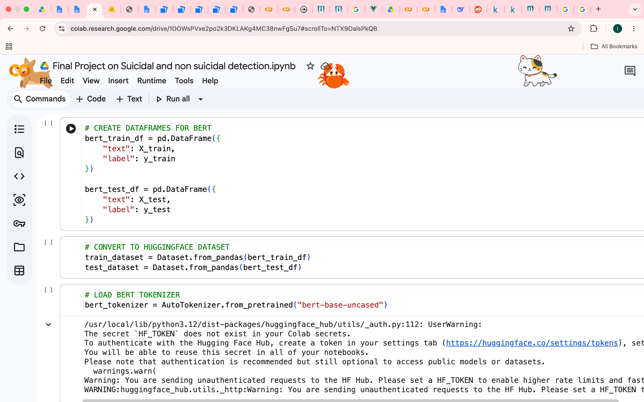
Figure 9 - BERT Fine-Tunning
Source - compiled by author

4. EXPERIMENTAL RESULTS
The performance of all implemented models was evaluated using accuracy, classification reports, confusion matrices, and graphs.

Models | Accuracies
Logistic Regression | 94%
Word2Vec | 91%
LSTM | 95%
Transformer | 94%
BERT | 98%

Source- compiled by author

The BERT model achieved the highest performance with an accuracy of 98%.
Several evaluation metrics were used:
- Accuracy
- Precision
- Recall
- F1-score
- Confusion Matrix
These metrics provided a detailed understanding of model performance.
The graph was generated during experimentation. The BERT model demonstrated the lowest validation loss and highest classification accuracy among all models.
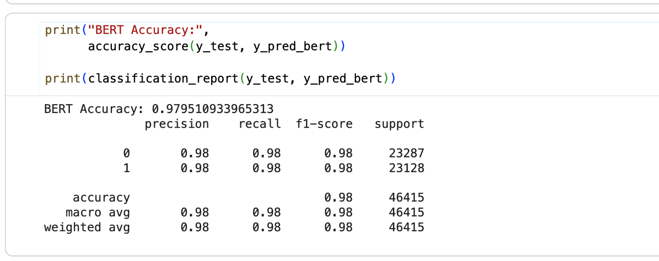
Figure - 10 - Bert Accuracy
Source - compiled by author

4.1 Model Comparison
Traditional machine learning models such as Logistic Regression performed reasonably well but lacked deeper contextual understanding.
Deep learning approaches such as LSTM and Transformer improved performance by learning sequential and contextual relationships within text.
Among all models, BERT achieved the best performance because of its pretrained bidirectional transformer architecture, which allowed it to better understand emotional context and semantic meaning in suicidal text.

5. DISCUSSION
The results showed that deep learning and transformer-based models significantly outperformed traditional machine learning approaches.

5.1 Model Strengths
- TF-IDF + Logistic Regression was simple and fast
- Word2Vec captured semantic relationships
- LSTM preserved sequential context
- Transformer handled attention and long-range dependencies effectively
- BERT achieved the best contextual understanding and highest accuracy
Some social media posts contained sarcasm, slang, or ambiguous emotional expressions, making classification difficult. The models may also struggle with highly informal or incomplete text. Deep learning models such as BERT also required higher computational resources and longer training time.

5.2 Observations
The experiment demonstrated that pretrained transformer models are highly effective for NLP classification tasks. BERT consistently outperformed all other models due to its bidirectional contextual learning ability.
It was also observed that preprocessing significantly improved classification performance by reducing dataset noise.

6. CONCLUSION
This project successfully developed a complete Natural Language Processing (NLP) pipeline for suicidal thought detection using both machine learning and deep learning techniques. The project followed all major stages of an NLP workflow, including data preprocessing, feature engineering, word embeddings, sequence modeling, attention mechanisms, transformer architectures, and BERT fine-tuning.
Several models were implemented and evaluated throughout the project. The results showed that traditional machine learning approaches were able to classify suicidal and non-suicidal text with good performance, while deep learning models achieved higher accuracy by learning contextual and semantic relationships within the text. Among all the implemented approaches, the BERT model produced the best results, achieving an accuracy of 97.95%. The classification report also showed high precision, recall, and F1-score values, indicating strong and balanced performance across both classes. Furthermore, the confusion matrix revealed that the model correctly classified the majority of posts, with only a small number of misclassifications.
The experimental results demonstrated that performance improved as more advanced NLP techniques were applied. Feature extraction methods such as TF-IDF provided a strong baseline, Word2Vec improved semantic understanding, LSTM captured sequential information, and Transformer architectures enhanced contextual learning through attention mechanisms. BERT ultimately achieved the highest performance because of its pretrained bidirectional transformer architecture, which allowed it to better understand the meaning and context of social media posts.
This project also highlighted the importance of proper preprocessing techniques such as lowercase conversion, punctuation removal, stopword removal, and tokenization. These steps reduced noise in the dataset and improved the quality of the text representations used by the models. The generated graphs, confusion matrices, and testing results further confirmed the effectiveness of the implemented approaches.
Overall, this project provided valuable practical experience in applying NLP and deep learning techniques to a real-world mental health classification problem. The results confirmed that transformer-based architectures are highly effective for suicidal thought detection and can serve as a foundation for future intelligent systems that support mental health monitoring and early intervention. Future improvements may include using larger datasets, multilingual text classification, real-time social media monitoring, and deploying the model as a web-based application for practical use.

REFERENCES
- Devlin, J., Chang, M. W., Lee, K., & Toutanova, K. (2019). BERT: Pre-training of Deep Bidirectional Transformers for Language Understanding. Proceedings of NAACL-HLT 2019, 4171–4186.
- Vaswani, A., Shazeer, N., Parmar, N., et al. (2017). Attention Is All You Need. Advances in Neural Information Processing Systems (NeurIPS).
- Hochreiter, S., & Schmidhuber, J. (1997). Long Short-Term Memory. Neural Computation, 9(8), 1735–1780.
- Mikolov, T., Chen, K., Corrado, G., & Dean, J. (2013). Efficient Estimation of Word Representations in Vector Space. arXiv preprint arXiv:1301.3781.
- Pedregosa, F., Varoquaux, G., Gramfort, A., et al. (2011). Scikit-learn: Machine Learning in Python. Journal of Machine Learning Research, 12, 2825–2830.
- Abadi, M., Agarwal, A., Barham, P., et al. (2016). TensorFlow: Large-Scale Machine Learning on Heterogeneous Distributed Systems. arXiv preprint arXiv:1603.04467.
- Wolf, T., Debut, L., Sanh, V., et al. (2020). Transformers: State-of-the-Art Natural Language Processing. Proceedings of EMNLP 2020.
- Bird, S., Klein, E., & Loper, E. (2009). Natural Language Processing with Python. O’Reilly Media.
- Harris, C. R., Millman, K. J., van der Walt, S. J., et al. (2020). Array Programming with NumPy. Nature, 585, 357–362.
- McKinney, W. (2010). Data Structures for Statistical Computing in Python. Proceedings of the 9th Python in Science Conference, 51–56.
- Hunter, J. D. (2007). Matplotlib: A 2D Graphics Environment. Computing in Science & Engineering, 9(3), 90–95.
- Reimers, N., & Gurevych, I. (2019). Sentence-BERT: Sentence Embeddings using Siamese BERT-Networks. Proceedings of EMNLP-IJCNLP 2019.
- Brownlee, J. (2017). Deep Learning for Natural Language Processing. Machine Learning Mastery.
- Chollet, F. (2021). Deep Learning with Python (2nd ed.). Manning Publications.
- Kaggle. (2024). Suicide and Non-Suicide Text Dataset. Retrieved from https://www.kaggle.com/

